Religion and Politics in Asia
Classical Civilizations Name: ____________________________________
Unit One - World History

Hinduism

Key Terms
- Vedas or Vedic texts
Holy texts of Hinduism
Hindus believe that the texts were received by scholars direct from God and passed on to the next generations by word of mouth.
- Reincarnation
Constant death and rebirth of the soul through various forms
- Caste system
Social organization as outlined by the Laws of Manu
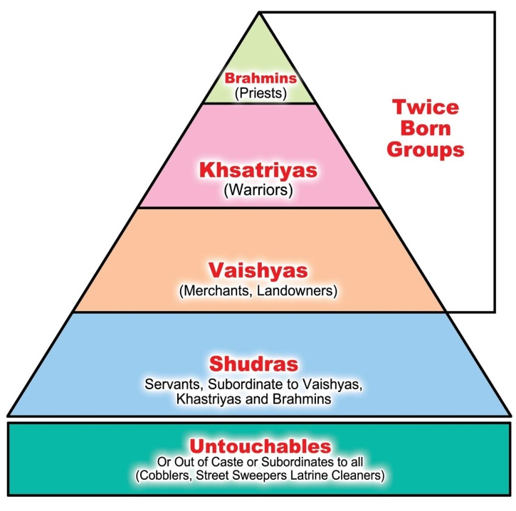
- Karma
Actions of your present life that define the outcome
of your reincarnation
- Samsara
Constant cycle of death and rebirth
- Moksha
Final release from the cycle of reincarnation
- Dharma
Your duty to your caste (ex. Born a Kshatriya = you
must be a warrior)

Dates
1500 BCE-Modern Era
Established after the Aryan invasions which ended the Indus River Valley civilization

Summary
Hinduism is the religion of the majority of people in India and Nepal. It has over 900 million adherents worldwide. Most Hindus believe in a Supreme God, whose qualities and forms are represented by the multitude of deities which emanate from him. About 80% of the Indian population regard themselves as Hindu.

Buddhism

Key Terms
- Siddhartha Gautama
  - Founder of Buddhism
- Enlightenment
  - State of perfect being - Buddha reached Enlightnement under a bodhi tree; When you reach enlightenment your soul exits reincarnation
- Reincarnation
  - Constant death and rebirth of the soul through various forms
- Nirvana
  - Final release from the cycle of reincarnation
- Eightfold Path
  - Buddha’s path to Enlightenment:
    - Right Understanding
    - Right Intention
    - Right Speech
    - Right Action
    - Right Livelihood
    - Right Effort
    - Right Mindfulness
    - Right Concentration
- Four Noble Truths
  - The truth of suffering (Dukkha)
  - The truth of the origin of suffering (Samudāya)
  - The truth of the cessation of suffering (Nirodha)
  - The truth of the path to the cessation of suffering (Magga)

Dates
6th century BCE

Summary
Buddhism is a spiritual tradition that focuses on personal spiritual development and the attainment of a deep insight into the true nature of life. There are 376 million followers worldwide.

Application
- Based on the map below, where did Buddhism diffuse?

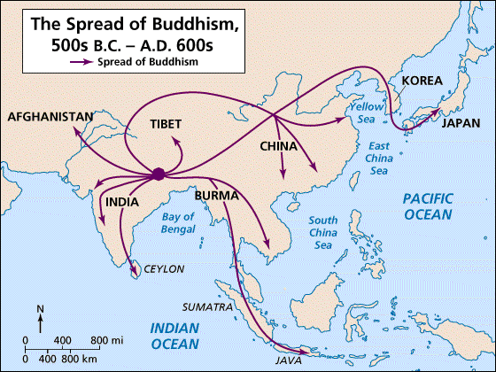
2. Based on the map below, what impact did the spread of Buddhism have on the current population of believers today?(note the populations of the countries where Buddhism spread to)

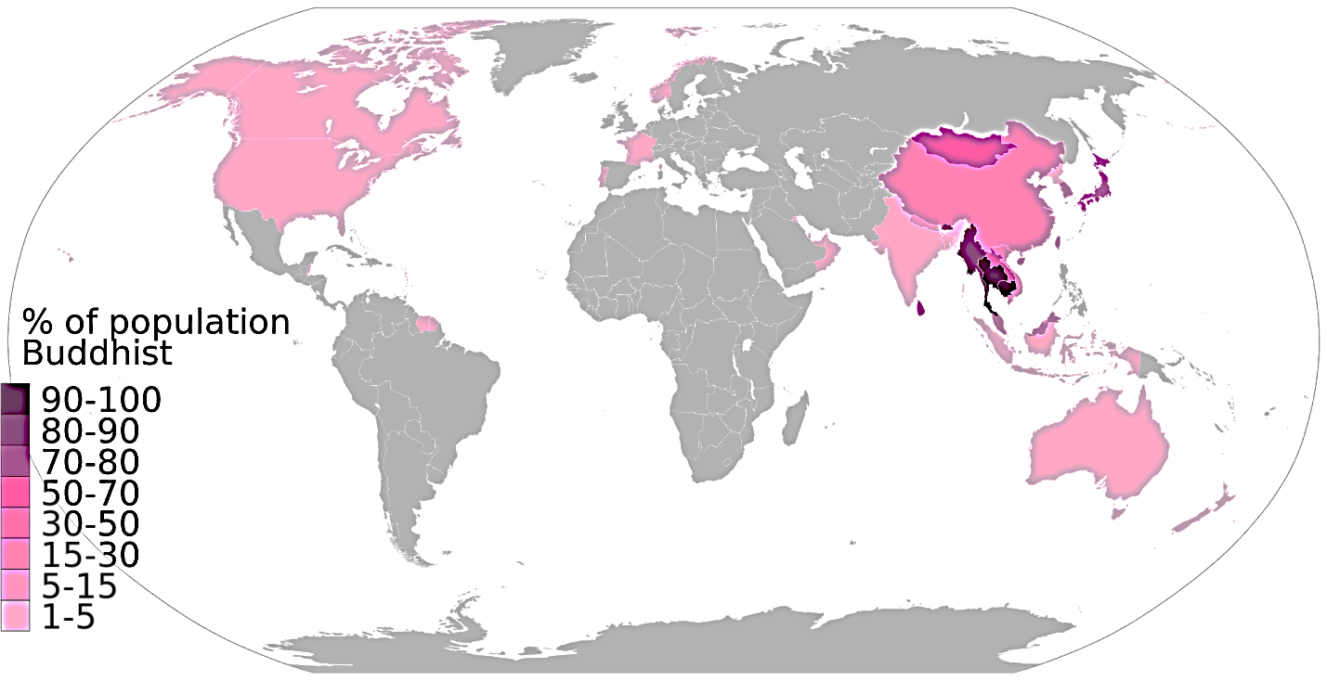

3. Based on the map below, what can you conclude about the impact of Buddhism on the Indian subcontinent?

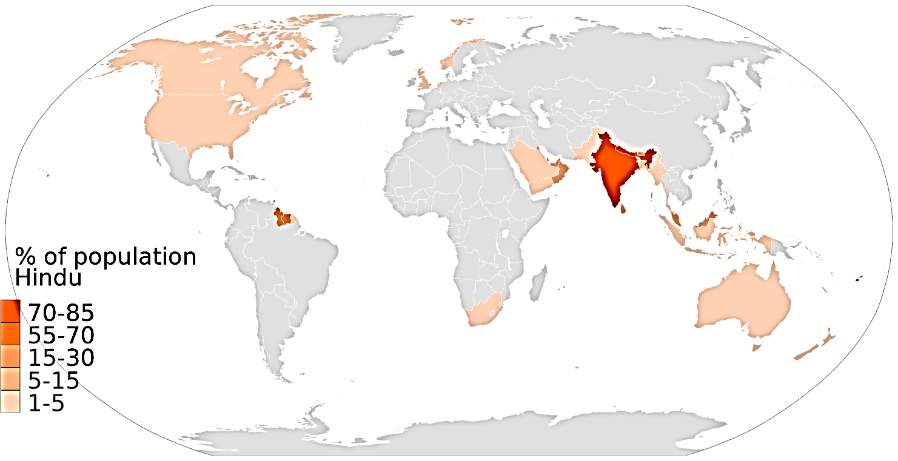

4. Conclusion: Based on what you’ve just read and seen, why do you think Buddhism spread from India and Hinduism remained in India?

Mauryan Empire and Ashoka
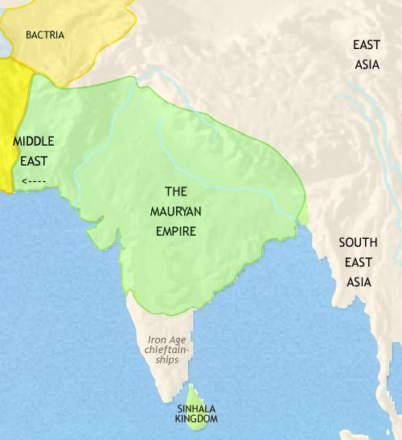
Throughout most of India’s history the subcontinent has remained fairly decentralized; power was held in the hands of princes rather than great emperors like China. While politically decentralized, India was almost always united culturally through Hindu values. There were few times throughout Indian history in which the subcontinent was unified: Mauryan Dynasty, Gupta Dynasty (4th c.-6th c. CE), Mughal Empire (16th c), modern Republic of India.
In 322 BC, Chandragupta Maurya founded the Mauryan dynasty in present-day Eastern India. Before the Mauryans, there had been hundreds of private kingdoms and armies, but the central government formed by Chandragupta Maurya provided a stable, unified nation. This political and military unity used regional governors to control justice and security, and let all kinds of trade expand and thrive. The trade that India engaged in along the Silk Road flourished because of the decreased number of bandits on the roads, and the internal trade also did well because of the single currency that Chandragupta established in India.
Buddhism, practiced by the emperor Ashoka after the Kalinga War, brought social and political peace to all of India. The expansion of science and knowledge also benefited the Mauryan dynasty and Ashoka in the era after the Kalinga War. Ashoka advocated for Buddhism to replace Hinduism as the key belief system. A particular story telling that Ashoka built 84,000 stupas (commemorative Buddhists buildings used as a place of meditation), served as an example to many Chinese and Japanese rulers who imitated Ashoka’s initiative.
Despite Ashoka’s effort, Buddhism did not remain the key religion of India. Hinduism held a decentralized India together cultural throughout the course of its history.

6. Why did trade flourish (expand/spread) during the time of the Mauryan Empire?

7. Why do you think Ashoka started to practice Buddhism (use prior knowledge of values of Buddhism)?

8. Why do you think Buddhism didn’t last in India?

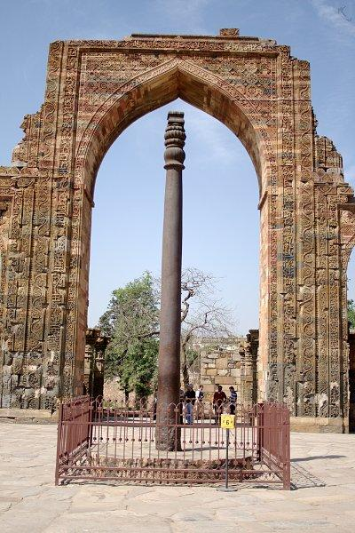
Golden Age of India
• After Asoka, collapse of Maurya Empire led to 500 years of conflict
• Gupta family took over—Chandra Gupta I began rule 320 CE
• India had golden age during reign of Chandra Gupta II, 375-415 CE

Art and Literature
• Arts (architecture, murals, statues) thrived under Chandra Gupta II
• Kalidasa’s famed Sanskrit plays, poems include Sakuntala love story

Mathematics, Science, and Metallurgy
• Indians invented our numeral and decimal systems, symbol for zero
• A mathematician figured length of year, value of pi
• Doctors expanded Ayurvedic medicine, worldʼs oldest medical system
• Artisans developed advanced metallurgy (metal working) - included 23-foot iron pillar over Delhi - no others made a piece of iron as large until 1,000 years later

Trade Spreads Indian Culture
• Gupta India profited from foreign trade by selling cotton, ivory - bought items such as silk from China; resold to traders going west
• Traders and missionaries spread Indian culture, beliefs - Hinduism spread to parts of Southeast Asia - Buddhism spread to Central Asia, Sri Lanka, China, Southeast Asia

Application:
9. Why was the period of Gupta rule a golden age for India?

10. Do you think trade helped the golden age or do you think the golden age helped trade?

Why It Matters Now . . .
The spread of Hinduism and Buddhism shaped Asian cultures. Many Asian people still practice those religions today.

Chinese Timeline
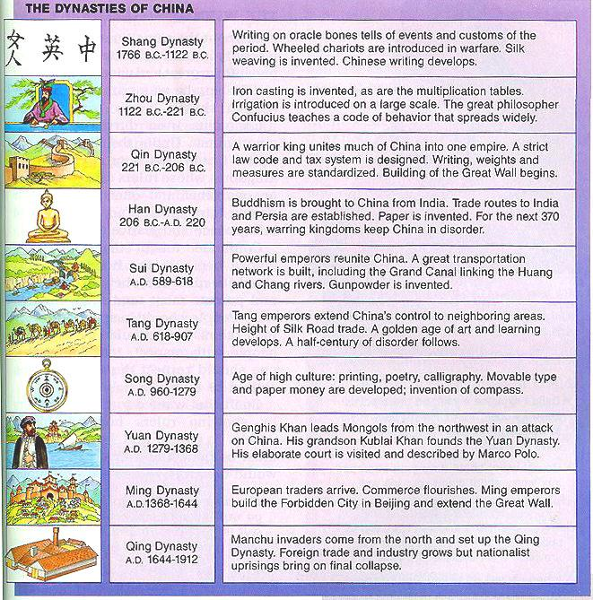
Under the Zhou dynasty, life in China was relatively decentralized with local lords ruling over their estates with peasant labor. Centralized government was in place, but it loosely controlled the feudal type lords. In the Zhou dynasty, no one religion was dominant, however due to geographic isolation, the Chinese developed a unique belief system based on ancestor worship.
Following the fall of the Zhou, China faced a time of violence, chaos, and disorganization. This is referred to as the Warring States Period. During this time period new philosophies like Confucianism and Daoism emerged as a response to the chaotic time. Confucianism advocated for order through respect and Daoism reinforced balance with nature through meditation. Both of these ideas are reflective of the desire for order and balance in a chaotic time in Chinese history.
The next dynasty to restore order was the short-lived dynasty of Shi Huangdi in the Qin Dynasty. Shi Huangdi had no successors and failed to create a true dynasty but did restore order through his harsh tactics. Shi Huangdi practiced Legalism, which enacted harsh punishments for violating any government law. Regardless of Shi Huangdi’s efforts to destroy Confucian and Daoist values, the two philosophies still live to influence Chinese history, government, and cultural practices today. The ideas of Confucianism also spread to Japan, Korea, and Vietnam.

Confucianism

Time Period
Warring States Period - Between Zhou and Qin Dynasties - 6th and 5th centuries BCE

Political History
- Dynasty
  - Throughout Chinese history the government has been ruled through dynasties, or a series of rulers from the same family.
  - The last dynasty was the Qing Dynasty which ended in 1911 CE. Since, China has been ruled by a variety of political systems.
- Mandate of Heaven
  - During the dynastic period of Chinese history, individuals believed the dynasty and their family must maintain the mandate of heaven, which was permission to rule from the gods. If they lost this mandate of heaven, the gods would make it known (through natural disasters and/or revolts) and the family would lose their right to rule.
- Dynastic Cycle
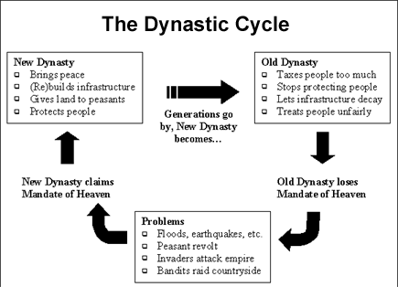

- Patriarchy
  - Historically, China remained patriarchal, mainly due to the male-dominance in Confucianism and the political system (male-heir)
- Examination System
  - Starting with the Han dynasty in Classical China, the examination system was used to determine one’s political status. The exam was rigorous and consisted of Chinese Classics and knowledge of Confucian texts. One must pass the examination system to gain a position in the government. This resulted in a highly organized government with specific rules and procedures (bureaucracy) which enabled China to function in a dynastic form until the 20th century.

Questions:
- If you had to summarize early Chinese history and culture in 5 key terms, what would they be?

- What cultural practices in ancient and classical Chinese history do you still see today in the country?

- Based on the map below, how did China influence surrounding Asian areas?

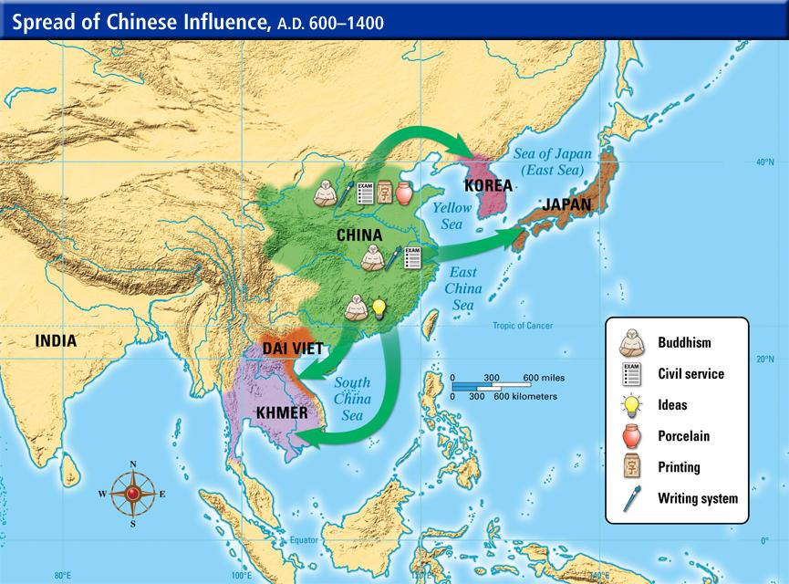

4. Explain the rise and fall of Chinese dynasties according to the dynastic cycle.

5. Why was the dynastic system of China able to last thousands of years?

6. Why do you think Shi Huangdi attempted to outlaw Confucian texts?

7. Do you think the Civil Service Exams were a good idea, and if so why? Were they negative in any way?

